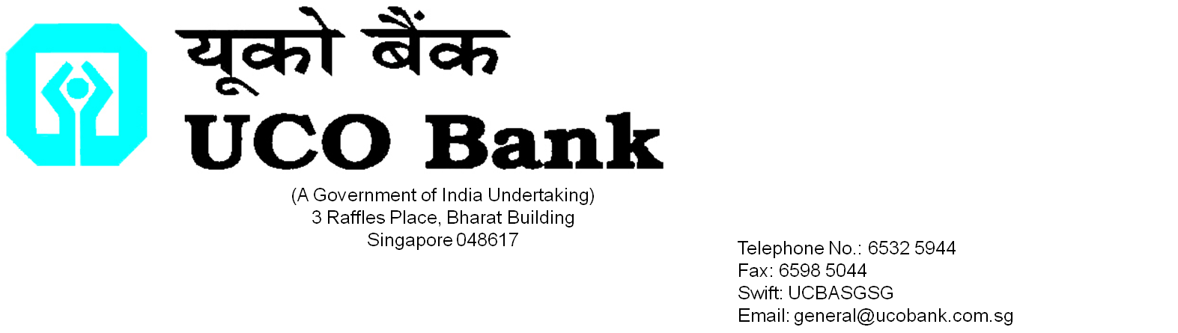

**To: UCO BANK, SINGAPORE Date: _______________**

**Office: _______________**

**APPLICATION FOR FREIGHT LOAN**

**FINANCE AMOUNT ………………………………………**

|  |  |
| --- | --- |
| Applicant’s Name and Address | Contact Person  Tel Number  Please debit all charges from our account :  USD /SGD Account No |

|  |  |  |  |
| --- | --- | --- | --- |
| Documents attached ( please fill in the number) | | | |
| Type | Commercial Invoice | Bills of Lading/AWB |  |
| Copies |  |  |  |

|  |  |  |
| --- | --- | --- |
| We submit herewith the following invoices | | |
| Invoice Amount | Date of Invoice | Freight Charges |
|  |  |  |

|  |  |
| --- | --- |
| **Payment details** | |
| Value Date |  |
| Amount in figures and words |  |
|  |
| Intermediary Bank |  |
| Beneficiary Bank |  |
| Beneficiary  (full address required) |  |
| Details of Payment |  |
| Details of Charges | SHA/OUR/BEN |
| Other instructions if any: | |
|  | |

|  |
| --- |
| We agree and accept the terms and conditions representations and warranties below |
| 1. We represent and warrant that this financing is for a genuine and bona fide trading transaction which is legal in all relevant jurisdictions and that the information and copies of any documents furnished in relation to this application is true accurate and complete. We further confirm that we have not obtained any other financing in connection with the enclosed documents, the title documents of the Goods, the Goods, the sale proceeds of the Goods and/or insurance proceeds in relation to the Goods; 2. We warrant that the loan to be extended by you to us shall be used only for payment of freight incurred or to be incurred for carriage of the Goods, and that the purchase of the Goods is financed by the Letter of Credit issued by you. We will repay you the full loan amount or financing extended to us by you on the due date stipulated by you, as well as any outstanding interest, charges, fees and commissions due to you. 3. We will at your request forthwith provide other documents and/or information evidencing the transaction 4. We agree to all terms and conditions set out in your general banking terms and conditions and/or any letter of offer or any facility letter from you to us. 5. We irrevocably consent to any disclosure by you, your employees and your agents, account information and personal data relating to us, any information relating to the Goods, the transactions in relation to the Goods, to:  * Your Head Office, related companies or branches in any jurisdiction * Any regulatory or supervisory authority in any jurisdiction; * Any potential assignees; * Any independent contractors of yours; * Any insurers with whom insurance is taken out in relation to the Goods;  1. Any demand, notice, communication, originating process, court documents and/or any documents to us may be sent by post to our address as set out herein or at our last known place of business. 2. If there are two or more signatories herein, then all obligations shall be joint and several. 3. The governing law of this transaction shall be the law of Singapore and any disputes in relation to this transaction shall be subject to the non-exclusive jurisdiction of the Courts of Singapore. |

Authorised Signatory/ies with Company Stamp

|  |  |
| --- | --- |
| SV |  |

___________________________________________________